CS4640 A<5>

<Yingjie Lian>

October 14, 2019

**Question 1 Answer:**

For this question, I first construct a char set:

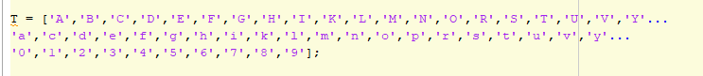

Then I have used BoudingBox to create a 25x15 template.

And follow the equation to find out the measures



**Question 2 Answer:**

For this question, I have used what professor provided in his CS4640_week8.m notes.

After finding the robust starting point, I have used bwboundarytrace three times

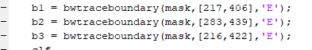to get the boundary points.

Then I have coerced them to be the same length using 75 pixels.

Here is what I got performance per character and overall.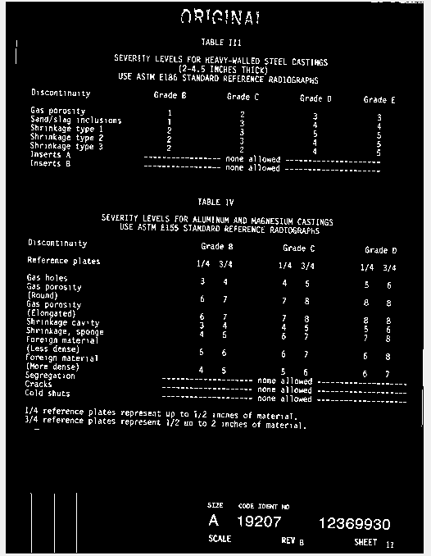Original chars45 picture.

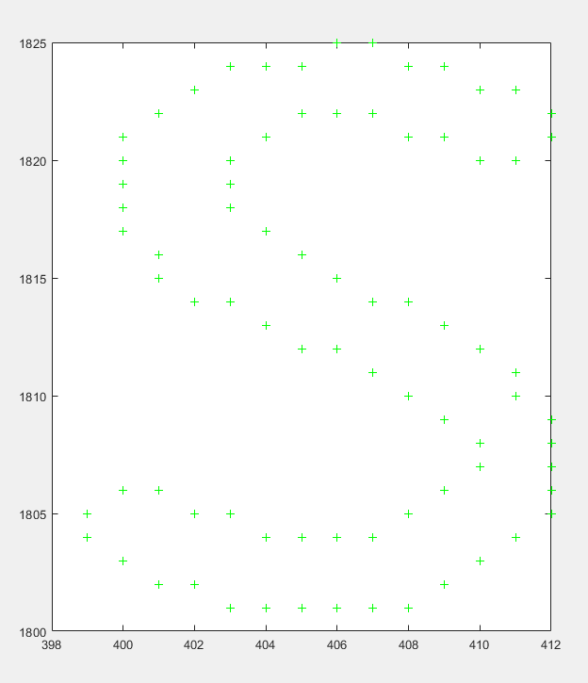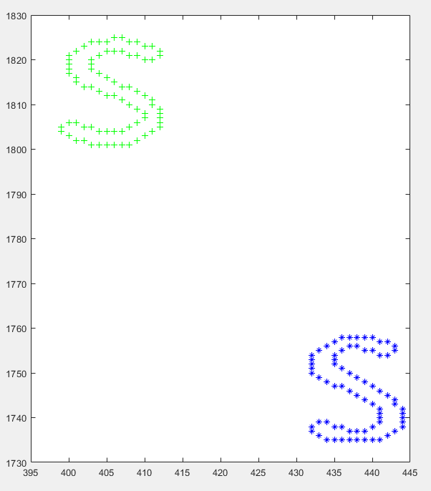

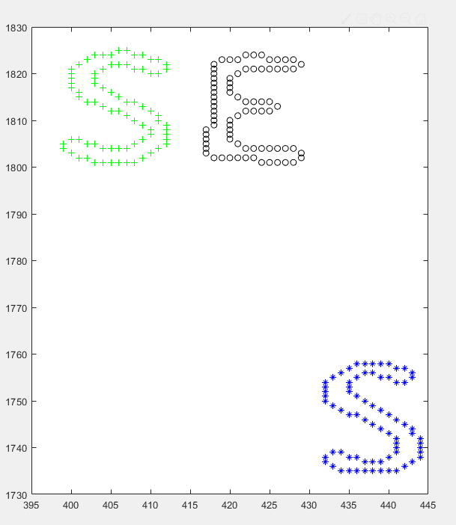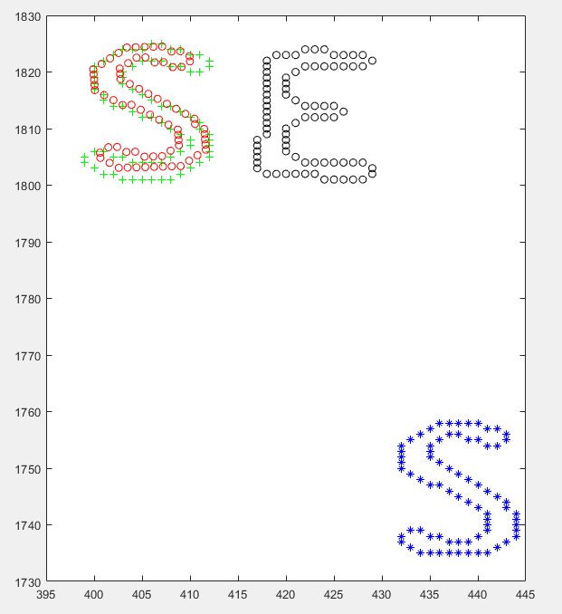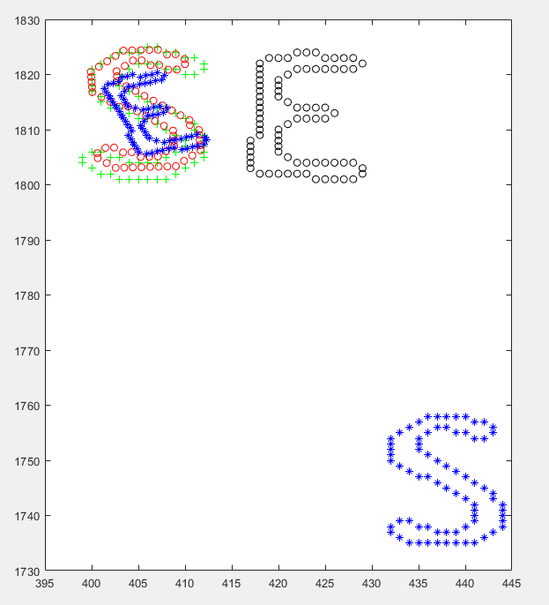

**Question 3 Answer:**

For this question, since we are going to find the perspective transform between

two point sets.

So I first, construct two points sets to make sure I can test for it.



Then, I have used cp2tform function to find the perspective transform.

I have also set my measurepoint to [60, 160].